<Title Pending>

He pulled the keyless entry car key fob from his pocket and pushed the lock button twice. Nothing.

He walked to the next aisle of cars and pushing the lock button again – *click click*. Nothing. No flashing headlights. No familiar honk. Just a sea of cars, on a 90⁰ day, a tub of ice cream in one hand, a pack of earplugs in the other.

Frustrated and needing to relax, our hero starts throwing his car key fob and catching it continuously. He hears a honk from a car right by him as he throws his keys into the air. Startled, his keys hit the ground of the parking lot as he made no attempt to catch them. As he reached down to pick them up, he realized his mistake.

“Permit Parking Only. Towing enforced 24/7.” That’s what the partially obscured sign he’d seen had said. It was laying on the ground when he pulled into the lot. He’d seen the sign, but he’d been too distracted for it to register until now.

Now that the ice cream was melting, leaking out from under the lid, making his hand sticky. Now that his shin was throbbing. Of course, this would happen now. He sighed, picked up his keys and looked to see an elderly man approaching the car next to him.

“Excuse me, sir!”, our hero exclaimed. The elderly man slowly looked over at our hero and gently smiled.

“Can I help you?”, the elderly man asked, seeing the ice cream, car keys, + earplugs.

“Mind if I get a lift to the metro? Or better yet, may I use your phone to call the towing company? My phone is dead.”, our hero replied.

“I haven’t had a cell phone in years. It always bogs me down and is one more thing I have to remember to bring!”, the elderly man replied, laughing at the end.

“I can certainly give you a ride, all the way home in fact, if you’re willing to do me a quick favor. How does that sound?”, he continued.

“That sounds great! Thank you so much!”, our hero said, breathing a sigh of relief.

“What’s your name?”, the elderly man inquired.

“Varun”, our hero replied.

“Well, hop in Varun!”, the elderly man said as he gestured towards the passenger seat.

As Varun walker around the car to the passenger side, a nefarious smile grew on the elderly man’s face. Both of them got in the car and closed their respective doors.

“So, what’s the favor?”, Varun politely asked. The elderly man simply smiled gently once again, and started the engine. He pulled forward out of the parking space and headed towards the lot’s exit.

“So, tell me Varun,” the elderly man asked. “Were do you live?”

“I’m over on Canterbury Ave., about 5 or 6 miles from here.”

“Ah yes, Canterbury, lovely neighborhoods over there. And do you live there with your family?”

“I suppose that depends on whether you believe family is something you’re both into or something you choose.”

The elderly man braked as he came to the stop sign. He looked both ways and then turned right.

“Oh, Canterbury is actually back the other way.” Varun said, pointing over his shoulder.

“Of course, it is, but what about that favor you promised me?” A twinkle formed in the elderly man’s eye as he smiled, knowingly, at Varun.

“Right,” Varun remembered. “What is it you need help with?”

“Well, you see, I’m supposed to pick up a package from my friend’s shop. It’s a rather large parcel though. My friend is out of town this weekend; otherwise, I’m sure he and I could manage. But seeing how it’s just me and my old bones, I wonder if you wouldn’t mind helping grab it from the shop and load it into my car. I’d sure appreciate the help and will happily drive you home after.”

“Sounds straightforward.”

They both drove for another 30 minutes. At first, the conversation was alive and well, covering music, sports, and favorite restaurants in the area. As it slowly began to die down, Varun decided to fill in a couple gaps.

“So how far is your friend’s place?”

“Not too far. Just another 5 minutes actually.”

“Cool. Are we going to need to do anything else other than picking up this parcel?”

“Nope, that is all. I hope I haven’t bothered you too much with this request?”

“Not at all! I’m sorry about making you feel that way. I have a date later tonight, so was just hoping It wouldn’t take too long.”

“It won’t. We’ll be in and out in no time.” The elderly man flashed the key to his friend’s place.

5 minutes passed, and they arrived at the shop. A bit odd that a shop would be closed at 6pm on a Friday, Varun thought to himself.

They approached the door, and the elderly man used the key to unlock the door. A man was standing inside.

“Good work.” The mysterious man said.

“I thought you said your friend was out of town”, Varun asked the elderly man, his heat starting to race a bit more.

“This isn’t my friend!” The elderly man said, laughing heartily. He then continued “But this is the ‘parcel’ I was referring to.”, point at the mysterious man.

The mysterious man was tall and slender. He was dressed in a dark suit that appeared to be coated in a thin layer of dust. Varun scanned him up and down. He didn’t appear to be injured, but he wasn’t moving.

“I don’t understand,” Varun said. “I’m not OK with playing any part in human trafficking…”

The old man’s eyes widened and he let out a scoff. “Trafficking? Good grief what are you talking about? Now, I think it will be easiest if you just carry him to the car. Don’t be scared, he’s not going to bite!” he said seeing Varun’s hesitation.

“Go on now. I’ll hold the door.”

“Can you at least tell me where we are going?”

“Now now, that would take away the fun! I need you to trust me on this, Varoo.”, the old man replied.

“Did…did you just call me Varoo? That’s what my Mom called me…well, what she called me.” Varun said, with a regretful tone.

“Look, I’m sorry about what happened to Mom, but we’re running out of time. We must go now.”

For some reason, Varun *did* trust the elderly man. Varun decided to help. “Okay, fine. But I want answers soon!”

“Fair enough”, the elderly man chuckled.

Our 3 adventurers got into the car and drove…for over an hour. Varun tried working the mysterious man for answers, but he was at the Extra Space Storage Facility near Woodcliff Lake, north of East Rutherford, New Jersey.

“Please, follow me to the unit.” The elderly man requested.

“Alright. Let’s get this over with.” Varun said, gesturing for the mysterious man to accompany him, per request of the elderly man.

They all get out of the car and start walking. After taking a couple steps, Varun sees his moment is coming. He had noticed that the elderly man’s thin wallet was hanging from his jean back pocket. The mysterious man was just looking around, as if he had seen this place for the first time.

“Now!”, Varun thought to himself, seizing the wallet cautiously. He opened it up to see only 4 things, each more shocking than the last. There was only an ID and 3 pictures. The 3 pictures were what caught his eye first. His heart startled racing more than it ever had before. “This can’t be…”, he whispered to himself, yet it made sense. “Varoo…what happened to Mom…, it does checkout”

“You’re…you’re ME!!!”, Varun screamed. The elderly man turned back faster than he ever had before. “Alright, stay ca-“. Varun had fainted.

“I was hoping this wouldn’t happen again,” elderly Varun signed, “I’m getting too old for this. Elderly Varun knelt down to collect his wallet and its contents.

❶ 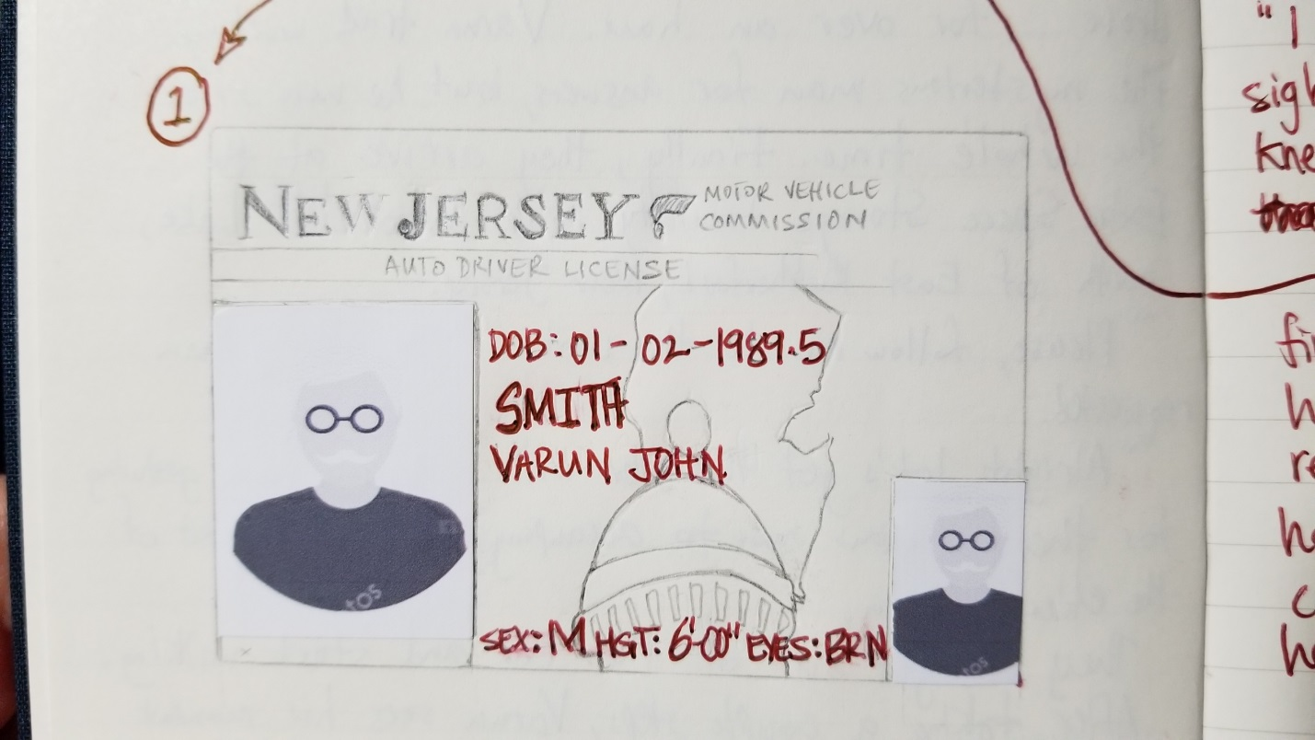

❷ Varun paused as he picked up the first photo, caressing its bent edges between his fingers. His mother had been his hero. A renowned documentary photographer, she had dedicated her life to animal conversation efforts through her art and her research.

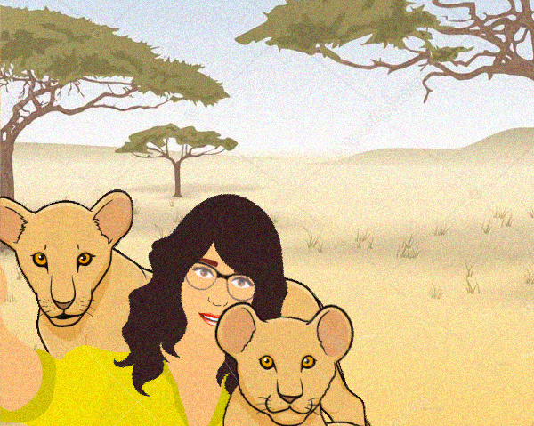Her last job had taken her to Africa to document a pride of lions. This was the last photo he received from his mother.

A week and a half later, he received a call. There had been an “accident” they said. She’d been documenting the pride on a hunt. She’d been up on the side of the ravine, the pride below, closing in on a herd of wildebeest when she slipped and fell into the stampede below. They never found her body or her camera. They told him it was better that way- Better to remember her alive, vibrant, and happy.

The second picture…

❸